Advance Computer Network Assignment 1
Submitted by: Aarav Kaim

- To capture live network packets using Wireshark and identify basic network protocols such as TCP, UDP, IP, and DNS.

Step 1: Launch Wireshark
- Open Wireshark
- You will see a list of network interfaces
  - Wi-Fi
  - Ethernet

Step 2: Start Packet Capture
- Double-click on Wi-Fi (or active interface)
- Packet capture will start immediately

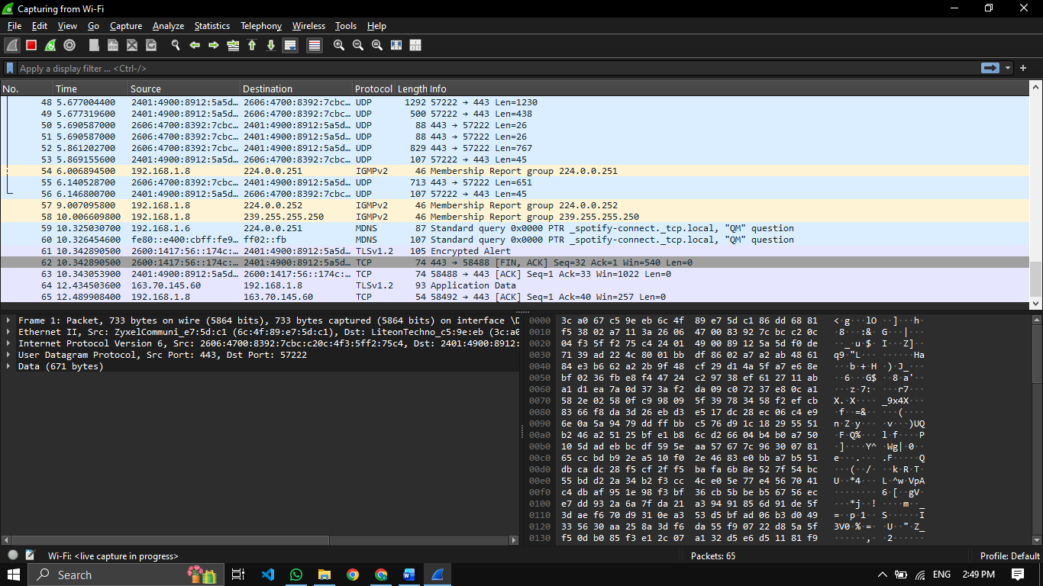

Step 3: Generate Network Traffic
Perform any of the following:
- Open a web browser
- Visit any website (e.g., google.com)
- Open Command Prompt and run:
- ping google.com

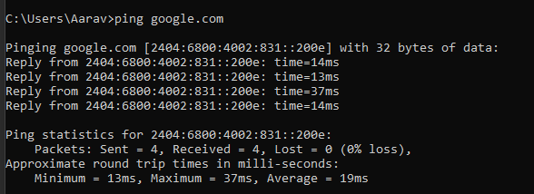

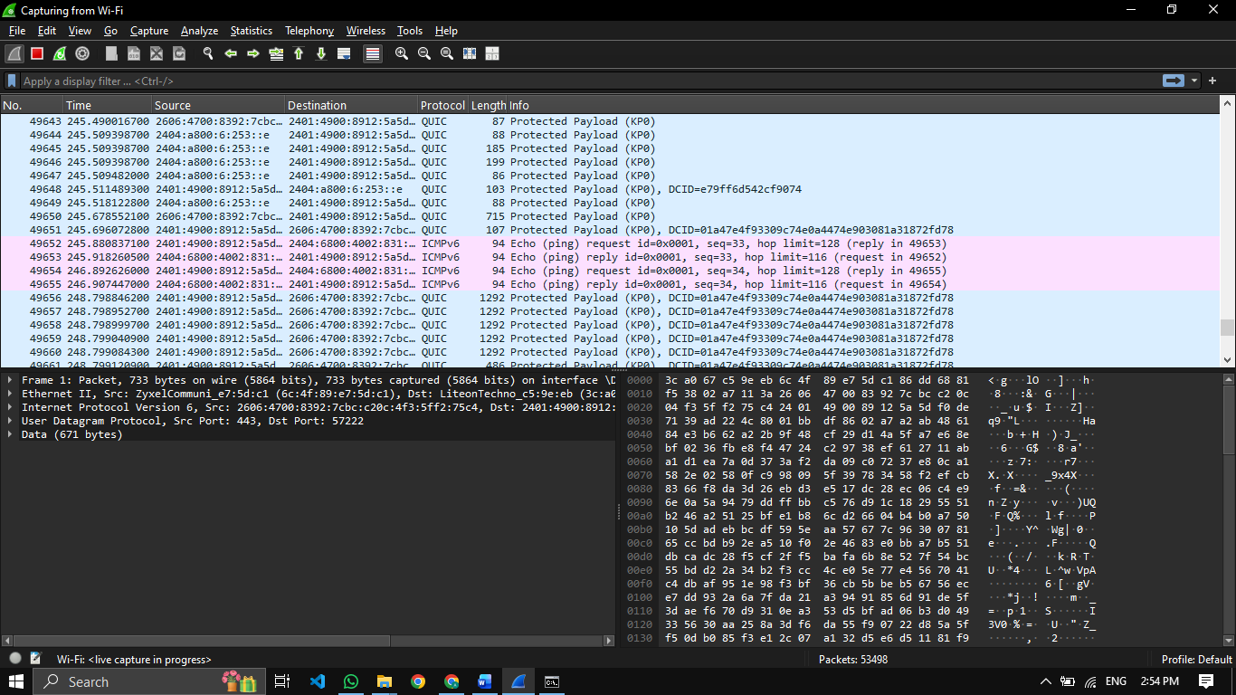

Step 4: Stop Capture
- Click the red Stop button
- Captured packets will remain on the screen

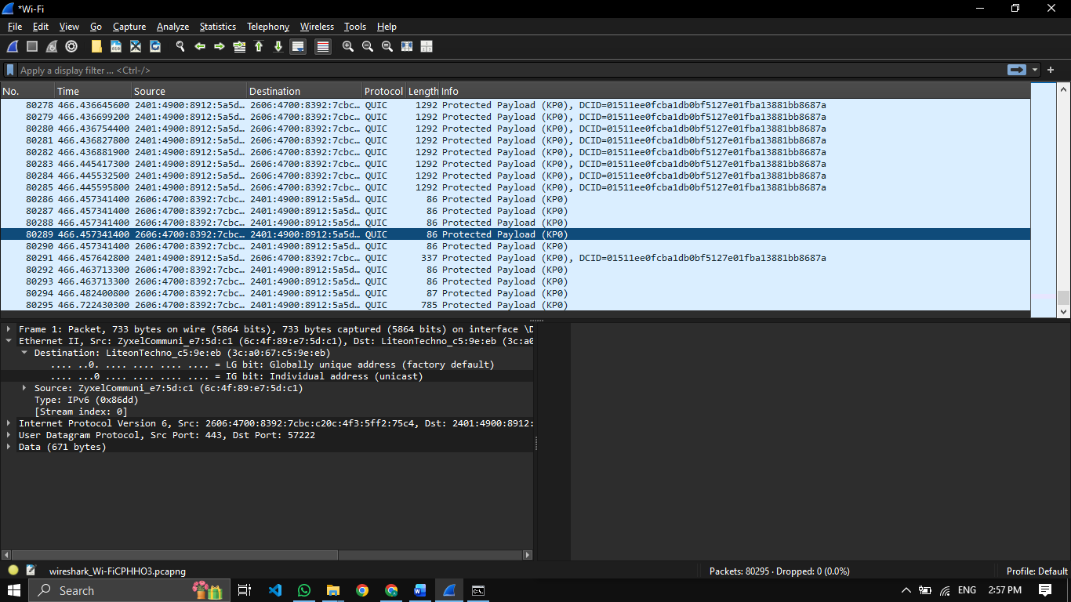

Step 5: Apply Basic Filters
Use the Display Filter bar:
Filter | Purpose
ip | Show IP packets
tcp | Show TCP packets
udp | Show UDP packets
dns | Show DNS packets
icmp | Show ping packets

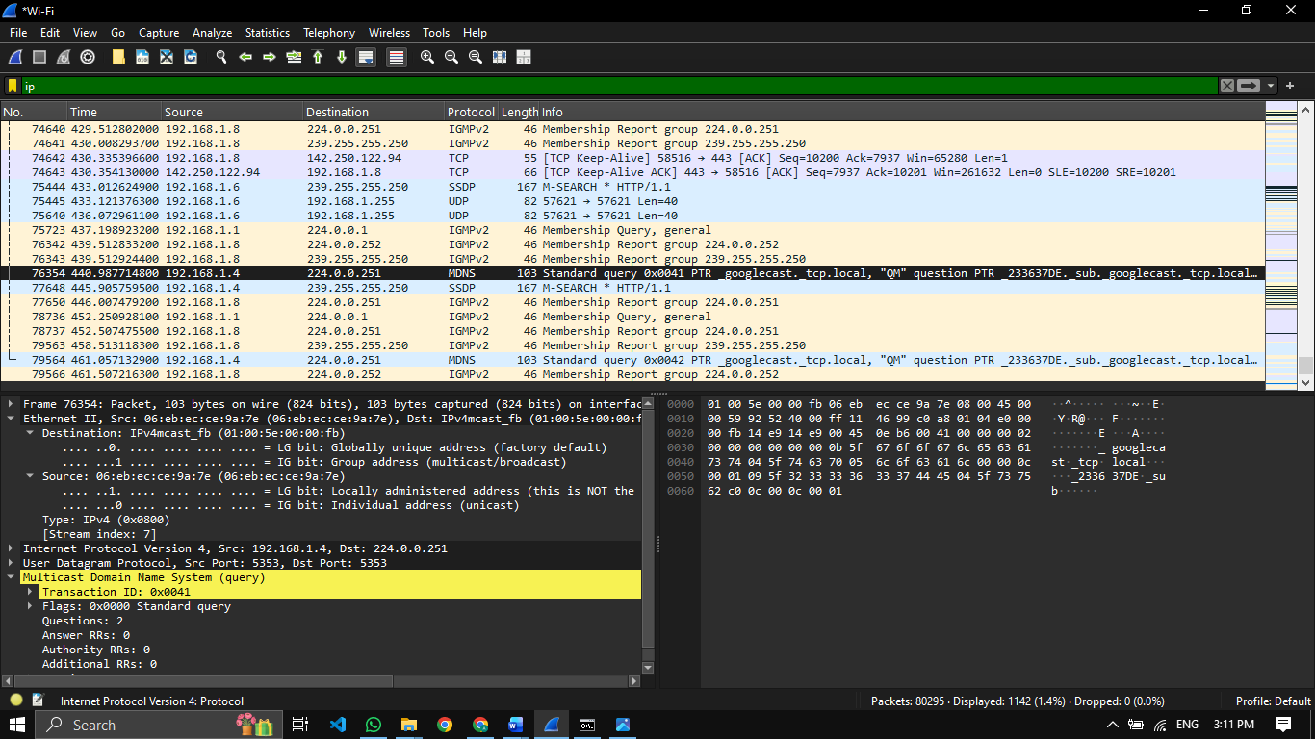
IP pakcets.

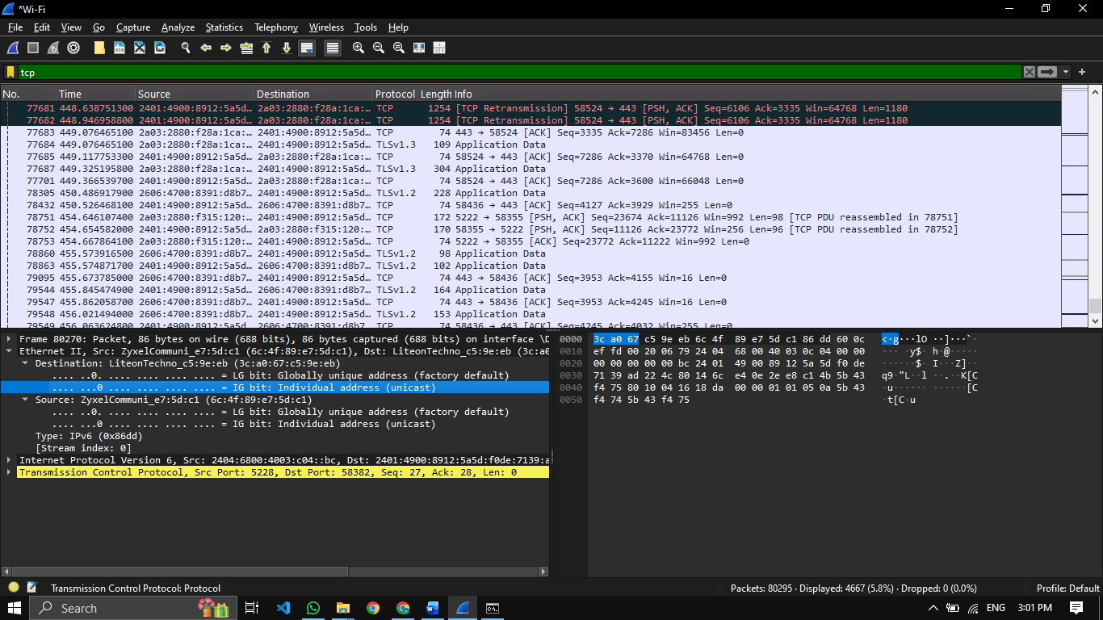
TCP packets.

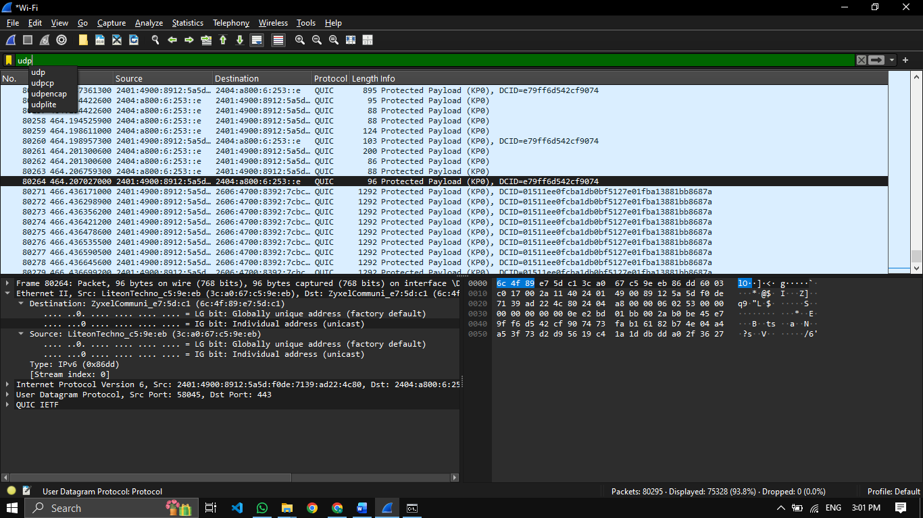
UDP packets.

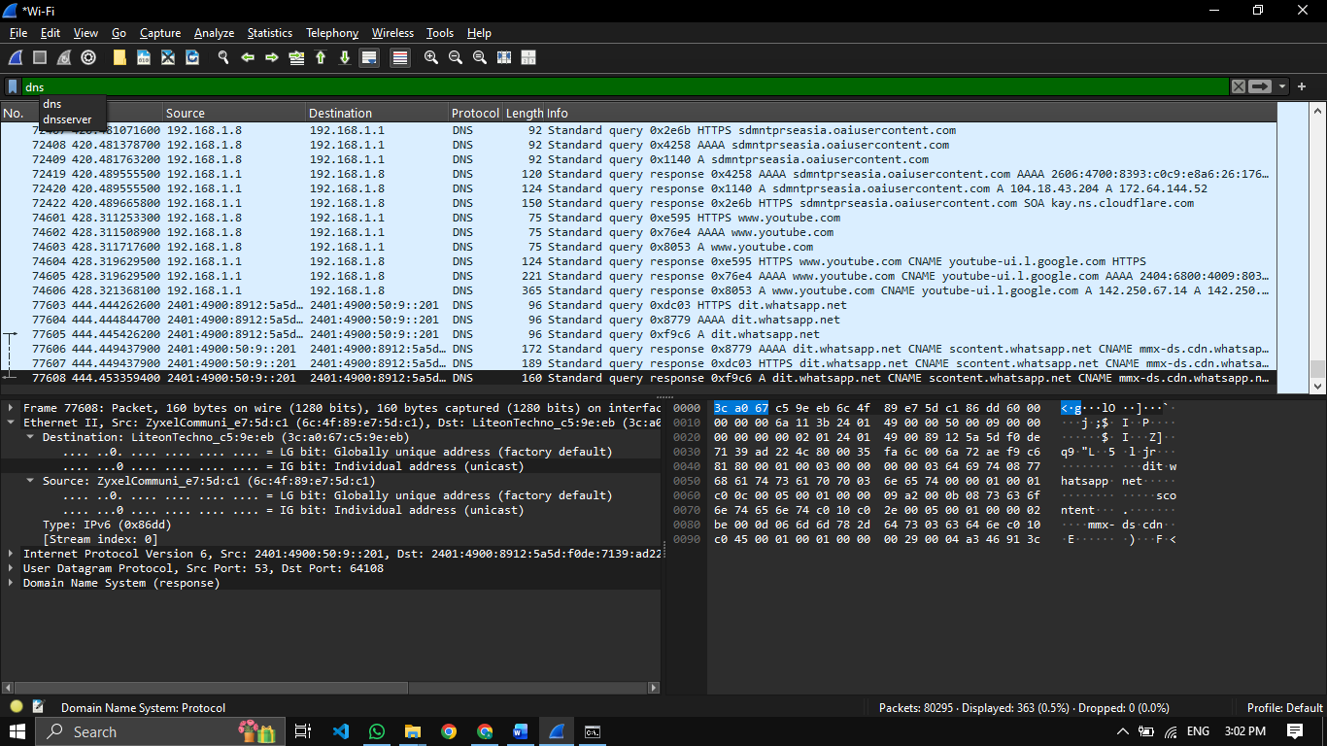
DNS packets


ICMP packets

Step 6: Analyze a Packet
- Click on any packet
- Observe:
  - Ethernet header
Source MAC Address: ZyxelCommuni_e7:5d:c1
Destination MAC Address: LiteonTechno_c5:9e:eb
Type: IPv4 (0x0800)

  - IP header
Version: IPv4
Source IP Address: 192.168.1.1
Destination IP Address: 192.168.1.8
TTL (Time to Live): 64
Protocol: ICMP (1)
Header Length: 20 bytes

  - TCP/UDP header – I used an ICMP packet. So, the TCP/USP header are not present.
Type: Destination unreachable (3)
Code: 3 (port unreachable)

  - Payload data
Source: 192.168.1.8
Destination: 192.168.1.1
Protocol: UDP (Port 137 – NetBIOS)

📊 Observation
- Interface used: WI-FI
- Protocols observed: TCP, UDP, DNS, ICMP
- Source and destination IP addresses: 192.168.1.1 & 192.168.1.8
- Packet length: 138 bytes

Result
Live network packets were successfully captured using Wireshark, and basic network protocols were identified and analysed.

